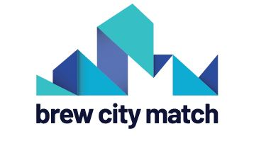
COVID-19 SMALL BUSINESS
GRANT APPLICATION

Eligibility: Any retail, restaurant, or service business within the Brew City Match program area is eligible to apply. To determine if you are in the program area visit www.brewcitymatch.com/resources and review the map.
Use of Grants: Funds may be used for either rental assistance or to meet payroll for current employees.
How to Apply: Mail completed applications along with required documentation to info@brewcitymatch.com.
Review Process: Applications will be accepted on a rolling basis. Businesses will be notified within five business days on the status of their application.

Contact Name: Business Name:

Business Address:

Phone Number: Email:

Amount Requested (max $1,200):
Intended Use of Funds:
󠅅 Rent
󠅅 Payroll for Existing Employees
How has your business been impacted by COVID-19:

Tell us a little bit more about your business:
Business type: 󠅀󠅀 Retail 󠅀 Restaurant 󠄹 󠅀󠅀 Service
Brief description of your business:
# of Employees on December 31, 2019: (full-time) (part-time)
# of Employees on March 30, 2020: (full-time) (part-time)
Annual Sales Revenue in 2019:
What is your gross annual income?
Do you rent or own your property? 󠅀󠅀 Rent 󠅀 Own
Monthly Rent or Mortgage payment:
Is your business women owned? 󠅀󠄹 Yes 󠄹󠄹 No
Is your business minority owned? 󠅀󠄹 Yes 󠄹󠄹 No

Required Documentation:
- If applying for rent assistance you must submit this form with a copy of your lease, along with a signed W9 form.
- If applying for payroll assistance you must submit this form with a copy of your payroll ledger or signed timesheets that indicate pay rate and total hours worked along with a signed W9.
- If awarded a grant you will be required to provide proof of payment along with a signed letter from the property owner indicating they are aware that the business received a grant through Brew City Match. You will have 30 days to provide this documentation.
Send all documents to info@brewcitymatch.com. Applications will be reviewed as they are received. Businesses will be notified of their application status within five business days.
For Reviewers:

Date: __________ BID: Documentation Provided: 󠅀󠅀 Yes 󠅀󠅀 No

Notes:

Reviewers Name: Approval Status: _________ Amount:

